**Velammal College of Engineering and Technology, Madurai**

**An Autonomous Institution**

**Department of Computer Science and Engineering**

**21CS205 Object oriented programming lab**

**Exercise** 10

Event driven Programming

Team 1

1. Create a new Java GUI application to convert miles to kilometers when pressing the “Convert!” button. Note that you need to implement the ActionListener interface and override the actionPerformed() method. Note that 1 mile is equal to 1.609 kilometers.
2. Write Swing program to view the color palette. Using the Slider create three Slider objects for the colors red, green and blue. The initial values for each color are set to 128. You choose your own values When you move the pointer on the Slider of each color, the corresponding color is displayed on the Graphics panel

Team 2

1. Create a new Java GUI application that moves a snowman on a panel. The position of the snowman can be changed using the control buttons. With the four buttons, a user can move the snowman to the left, right, up or down position.
2. Write a program in java to create Swing for selecting the background and foreground color of the text area control with the help of radio buttons

Team 3

1. Design a calculator using event-driven programming paradigm of Java with the following options.

a)Decimal Manipulations b) Scientific Manipulations

1. Write a program to display a counter using JFrame and multithreading

Team 4

1. Write a java program that simulates a traffic light. The program lets the user select one of three lights: red, yellow, or green with radio buttons. On selecting a button, an appropriate message with “stop” or “ready” or “go” should appear above the buttons in a selected color. Initially there is no message shown.
2. Write a java applet to draw the primitive shape (circle, square, rectangle) with the specified foreground and background colors using required radio button controls

Team 5

1. Write a Java program to toggle the background color on every click of button.
2. Write a java program to create a registration form.

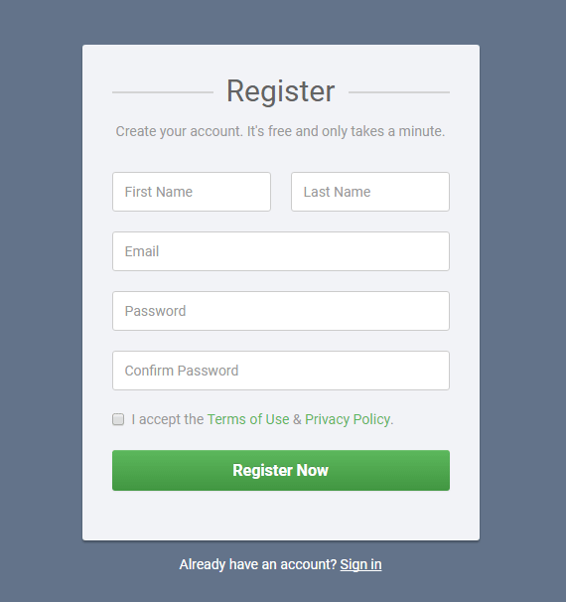

Team 6

1. Write a java program to plot the path of small circle moving around the circumference of a larger circle.
2. To write a java code to implement Color palette with matrix of Buttons Background and Foreground in control text area by selecting form color palette and selecting from the check box

Team 7

1. Develop a java application for the following scenario using Swing:Hamen’s Book shop maintains the inventory of books that are being sold at the shop. The list includes details such as author, title, price, publisher and stock position. Whenever a customer wants a book, the sales person inputs the title and author and the system searches the list and displays whether it is available or not. If it is not, an appropriate message is displayed. If it is, then the system displays the book details and requests for the number of copies required. If the requested copies are available, the total cost of the requested copies is displayed; otherwise the message “Required copies not in stock” is displayed.

Team 8

1. Create an application that models a simple sales terminal. You should be able to sell three kinds of items. Have one button for each item, and attach a picture of the item to the button. Each button should have three labels associated with it. These labels will display the price of the item, the number of that item sold in the current transaction, and a subtotal for that item. Each time a button is pressed, increase the count of that item in the current sale by one and update the subtotal. A separate tenth label should show the total cost of the current sale. An “EndSale” menu item ends the current sale and resets the totals to zero